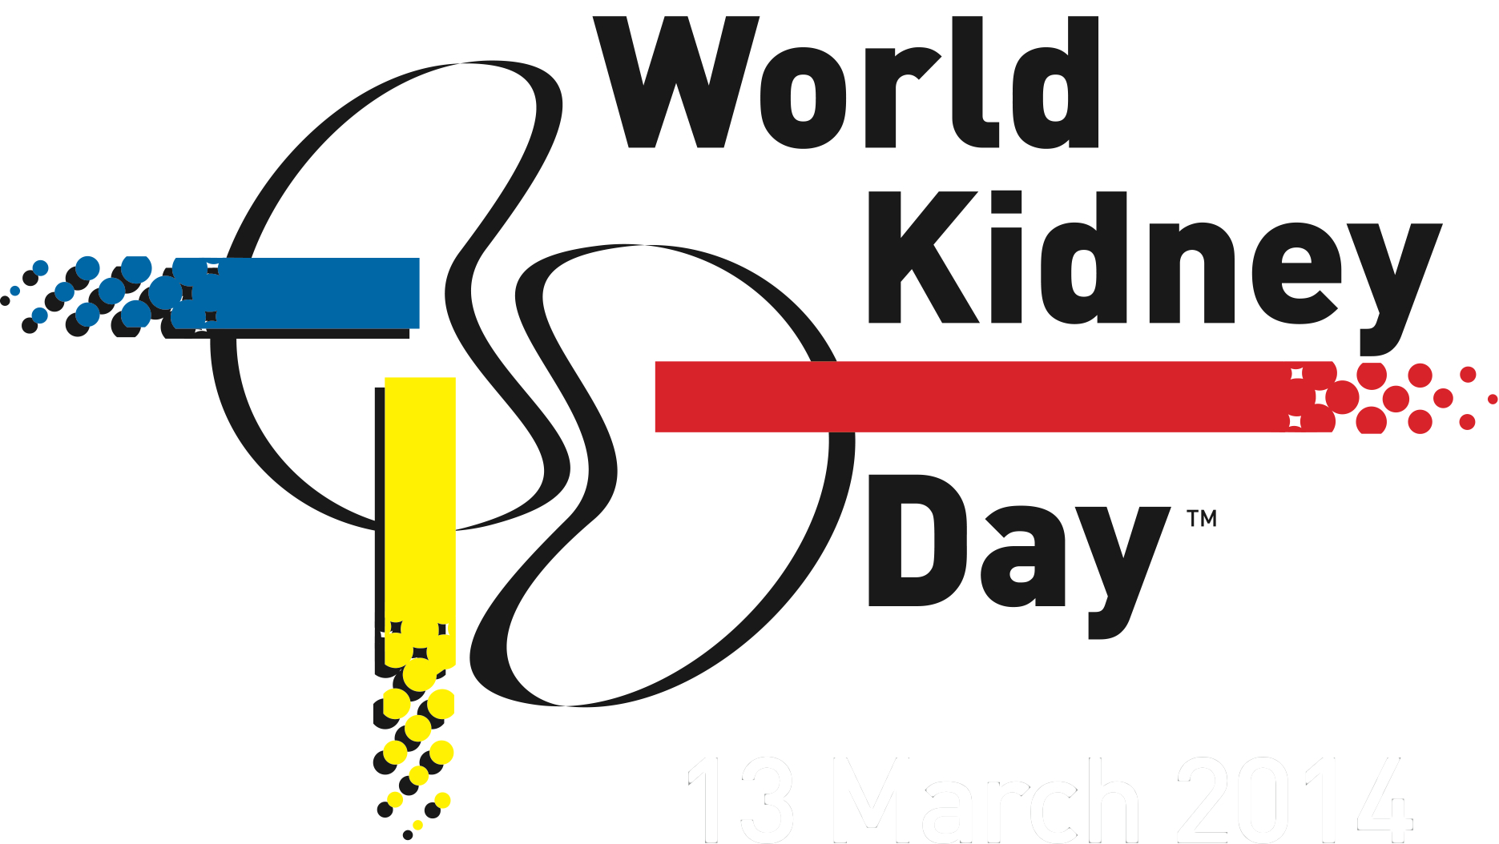

PRESS RELEASE

EMBARGO until February 28th
Kidney Disease & Obesity – Healthy Lifestyle for Healthy Kidneys
Support WKD by moving for your kidneys
Brussels, February 28, 2017 – 10% of the population worldwide is impacted by some form of kidney damage.

On Thursday March 9th we are celebrating the 12th edition of World Kidney Day (WKD), a joint initiative organized by the International Society of Nephrology (ISN) and the International Federation of Kidney Foundations (IFKF). WKD is the most widely celebrated event focused on kidney health across the globe. This year’s theme “Kidney Disease and Obesity” promotes education on the harmful consequences of obesity and its association with kidney disease, advocating a healthy lifestyle and healthcare strategy recommendations that tackle the magnitude of the burden of obesity and kidney disease.

Obesity has become a worldwide epidemic. In 2014 over 600 million people worldwide were affected by obesity and this number is expected to increase by 40% or more in the next decade. Obesity and overweight consitute the fifth highest risk factor for adult global deaths. This is because obesity, as it is well-known, is a risk factor of diseases such as diabetes, hypertension and heart disease.
A less well recognized (but equally important) complication of obesity is Chronic Kidney Disease (CKD). Obesity may cause chronic kidney disease through various ways. On the one hand, it could contribute to it indirectly, by inducing or worsening diabetes and hypertension, themselves well-recognized risk factors of kidney disease. On the other hand, obesity could also cause kidney damage directly, by placing an unduly high burden on the kidneys over many years (a larger body needs more kidney function after all), and also by causing harmful metabolic changes such as inflammation and oxidation.
It is estimated that 13,8% of CKD in men and 24,9% of CKD in women in industrialized countries may be associated with overweight or obesity. Besides its now well-recognized association with chronic kidney disease, obesity has also been recognized to be a risk factor for kidney stones, and for various types of cancers like kidney cancer and others. Individuals affected by obesity have an 83% increased risk of CKD compared to individuals with a healthy weight.
It is now clear that successful weight loss can result in improved control of diabetes and of high blood pressure, and it can lower the risk for developing chronic kidney disease.
“The best means to fight chronic kidney disease is prevention: it is thus paramount to identify and to treat all of its possible risk factors, such as obesity. Obesity is preventable and treatable, but reversing the tide will require concerted efforts not just from healthcare providers, but from the entire society", explains Dr. Csaba Kovesdy, Professor of Nephrology at University of Tennessee Health Science Center, Memphis, TN, US and Chief of Nephrology at the Memphis Veterans Affairs Medical Center.

This year the World Kidney Day promotes education on the harmful consequences of obesity and its association with kidney disease, advocating a healthy lifestyle and healthcare strategy recommendations to tackle the magnitude of the burden of obesity and kidney disease.

Share our Joint Position on Kidney Disease and Obesity!
Download and widely share our Joint Position on Kidney Disease and Obesity which World Kidney Day has developed in collaboration with the World Obesity Federation. In our Joint Position, we showcase key figures on the burden of kidney disease and obesity as well as the consequences of co-occurence. We also highlight a set of healthcare recommendations to encourage the acknowledgement of the magnitude of the burden of obesity and kidney disease, their correalating nature asrisk factors, and the implementation of a number of policy strategies to improve health outcomes!
You can download the Joint Position here!
On World Kidney Day, move for kidneys! – Keeping fit reduces high blood pressure and obesity, two of the leading causes of kidney disease.
This is why, leading up to March 9 and beyond, we encourage civil society, decision-makers, health ministries and professionals as well as patients to move for healthy kidneys. This gesture is a vivid reminder that regular exercise and physical activity help to reduce the risk of developing kidney disease. Moving is a simple yet powerful action that creates a link between our health and our daily routine.
Show your support online globally – Building on the great success of our WKD campaigns over the last years, which included over 600 reported events taking place in more than 80 countries and 87 million people talking about WKD on social media , we call on our community to share again their activities, messages and pictures online and get involved in the fight against kidney disease. For more information and details about World Kidney Day events worldwide – please see www.worldkidneyday.org
Participants can send us messages and their pictures, using #woldkidneyday.

Our campaign can be followed online on:

About the organizers of World Kidney Day:
World Kidney Day is a joint initiative of the International Society of Nephrology (ISN) and the International Federation of Kidney Foundations (IFKF).

Founded in 1960, the International Society of Nephrology (ISN) is a global not-for-profit society dedicated to improving kidney care and reducing the incidence and impact of kidney disease worldwide. Through its global network and programs, ISN brings together the developing and developed world in a collaborative effort in fighting and treating kidney disease on a global scale.
More information on www.theisn.org.

The International Federation of Kidney Foundations (IFKF), a not-for-profit Federation founded in 1999, currently has a membership of 63 kidney founations and patient groups in 41 countries. IFKF advocates worldwide to improve the health, well-being and quality of life of individuals with kidney disease; disseminates standards of best practice of treatment and care; assists with the establishment of kidney foundations in countries where they do not yet exist; facilitates educational programs for it members; and promotes kidney disease research.
More information on www.ifkf.org.

World Kidney Day Official Partners
World Kidney Day is grateful to the generous support of its global corporate contributors who help us make this day of global action possible. Thanks very much to:

- Our WKD Partners:

- Our WKD Supporters:

- Our WKD Benefactors: Akebia, Alexion, Baxter International Inc., and Fresenius Medical Care

Press contacts:
Agnese Ruggiero Tina Bielawska
World Kidney Day Campaign Manager PR Director, Ogilvy Public Relations
Email: agnese@worldkidneyday.org Email : tina.bielawska@ogilvy.com
Phone : +32 2 808 04 20 Mobile : +32-477-938256

