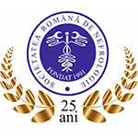
World Kidney Day 2018 – Romania, Constanta
Rinichiul și sănătatea femeii

Vivo Mall Constanta, Emergency Hospital Constanta County, 8th March 2018
Nephrology Department, Dialysis Department, Romanian Society of Nephrology, Ovidius University of Constanta, Emergency Clinical Hospital Constanta County
Organisers: Liliana-Ana Tuta, Alina Stanigut, Camelia Pana, Bogdan Campineanu, Ana-Maria Cornea, Dragos Fasie, Cristina Contineanu, Cristina Narla, Raluca Gheorghita, Sibel Abibula, Alina Bucur, Hermina Nicuta, Elena Ciciu, Antonia Ciaturi, Magdalena Nutu, Elena Moldoveanu, Ana Maria Oancea.

World Kidney Day comes back every year. Throughout the world, hundreds of events take place to promote awareness of good preventive behavior, risk factors and life with chronic kidney disease. This year, we focused our attention on kidney and women's health.
Because we value health and appreciate women, we invite you on 8th March 2018 at Vivo Mall Constanta, 13:00pm to 18:00 pm, in order to celebrate together World Kidney Day & International Women’s Day. Specialists will answer to your questions and we will all raise glasses of water in the honor of our healthy kidneys!
The event will include 3 speakers, specialists in Nephrology, Cardiology and Diabetology, which will disscuss about kidney's health and will answer to the questions from the public.
There will be a blood pressure measurement area by resident doctors, and an exhibition area, where people will learn about anatomy, physiology and pathology of the kidneys.
Specialists and resident physicians will share informative flyers, bottles of water, and kidney badges to all participants to the event.
We will promote the campaign via Facebook (posting articles about urinary infections, urinary lithiasis, diet in kidney diseases, CKD and CKD and AKI in pregnancy), printed materials and we will hold a press conference on 8th march at the Emergency Hospital Constanta County, at 10;30 a.m.

The printed materials will be:
• Roll-up Banner (85x200 cm)
• Brochures
• Gifts- urinary pH test strips, personalized water bottles
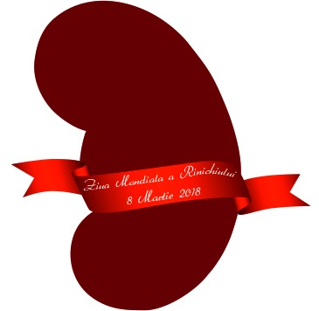
• Kidney badge “Martisor”

Still working at the Brochure

